**DLD Lab 8**

Q1) Implement Octal to Binary Priority Encoder on Bread Board by Using 74148 IC.

Circuit diagram:

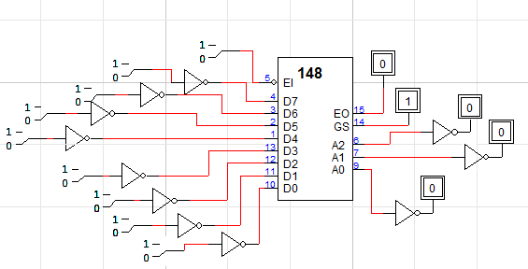

Truth table:

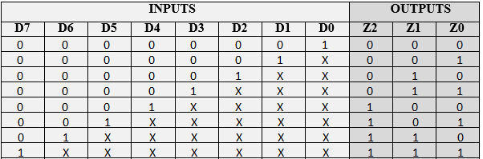

Q2) Implement Decimal to BCD Priority Encoder by Using 74147 IC.

Circuit diagram:

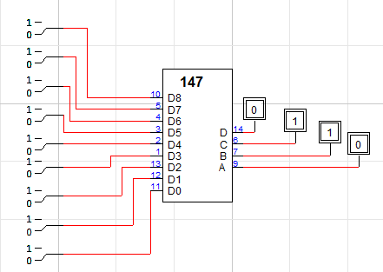

Truth table:

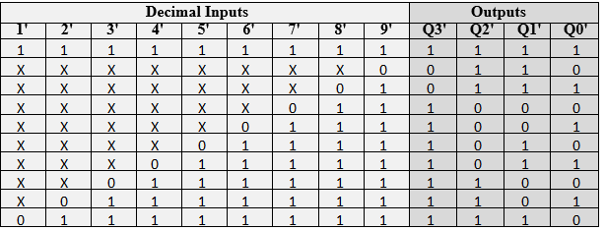

**DLD Lab 9**

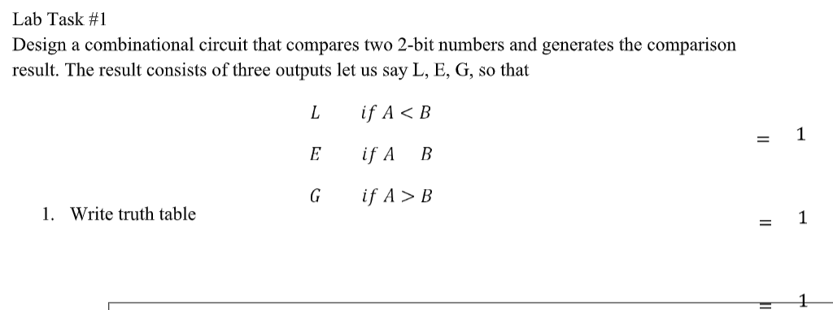

Truth table:

|  |  |  |  |  |  |  |
| --- | --- | --- | --- | --- | --- | --- |
| **INPUTS** | | | | **OUTPUTS** | | |
| **A1** | **A0** | **B1** | **B0** | **L** | **E** | **G** |
| 0 | 0 | 0 | 0 | 0 | 1 | 0 |
| 0 | 0 | 0 | 1 | 1 | 0 | 0 |
| 0 | 0 | 1 | 0 | 1 | 0 | 0 |
| 0 | 0 | 1 | 1 | 1 | 0 | 0 |
| 0 | 1 | 0 | 0 | 0 | 0 | 1 |
| 0 | 1 | 0 | 1 | 0 | 1 | 0 |
| 0 | 1 | 1 | 0 | 1 | 0 | 0 |
| 0 | 1 | 1 | 1 | 1 | 0 | 0 |
| 1 | 0 | 0 | 0 | 0 | 0 | 1 |
| 1 | 0 | 0 | 1 | 0 | 0 | 1 |
| 1 | 0 | 1 | 0 | 0 | 1 | 0 |
| 1 | 0 | 1 | 1 | 1 | 0 | 0 |
| 1 | 1 | 0 | 0 | 0 | 0 | 1 |
| 1 | 1 | 0 | 1 | 0 | 0 | 1 |
| 1 | 1 | 1 | 0 | 0 | 0 | 1 |
| 1 | 1 | 1 | 1 | 0 | 1 | 0 |

Circuit diagram:

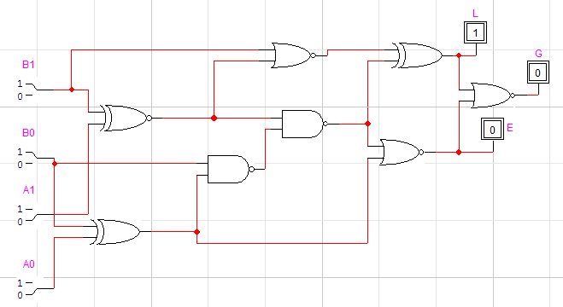



**L:**

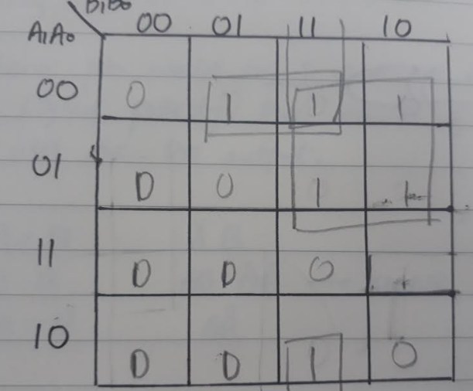

**SOP:** A1’B1 + A0’B1B0 +A1’A0’B0

**POS:** (A1’+B1)(A0’+A1’+B0)(A0’+A1+B0

**E:**

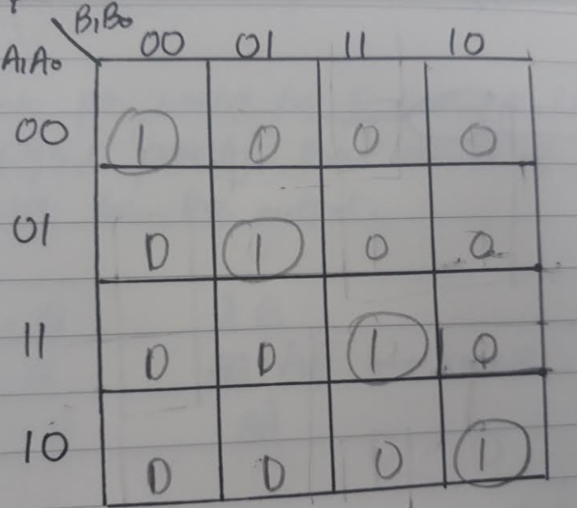

**SOP:** A1’A0’B1’B0’+ A1’A0B1’B0+ A1A0B1B0+ A1A0’B1B0’

**POS:** (A1’+A0’+B1’+B0’) (A1’+A0+B1’+B0) (A1+A0+B1+B0)(A1+A0’+B1+B0’)

**G:**

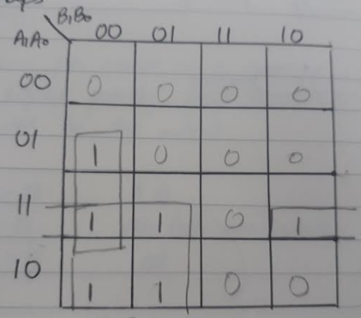

**SOP:** A1B1’ + A0B1’B0’ + A1A0B0’

**POS:** (A1+B1’)(A0+B1’+B0’)(A1+A0+B0’)